A
PROJECT SYNOPSIS
ON

" TinyML-Based Vibration Anomaly Detection System for Predictive Maintenance "
Submitted in partial fulfilment of the requirements for the award of the degree of

BACHELOR OF ENGINEERING
in
Electronics and Telecommunication Engineering
Submitted by
Armaan Ali (PRN No: 72329717H)
Atharva Nhavkar (PRN No: 72329900F)
Parth Ghare (PRN No: 72450689G)
Under the Guidance of
Prof. P.A.Patil

DEPARTMENT OF ELECTRONICS AND TELECOMMUNICATION ENGGINEERING
TSSM’s Bhivarabai Sawant College of Engineering and Research
Narhe, Pune-411041
Academic Year: 2026 - 27

CERTIFICATE
This is to certify that the project synopsis entitled “TinyML-Based Vibration Anomaly Detection System for Predictive Maintenance” is submitted by:
- Armaan Ali (PRN No: 72329717H)
- Atharva Nhavkar (PRN No: 72329900F)
- Parth Ghare (PRN No: 72450689G)
in partial fulfilment of the requirement for the award of the degree of Bachelor of Engineering in Electronics & Telecommunication Engineering, TSSM's Bhivarabai Sawant College of Engineering and Research, Pune-41, affiliated to Savitribai Phule Pune University, during the academic year 2026-27, as per the curriculum (Course 404188: Project Phase – I).
This synopsis represents the bona fide work of the above-named students carried out under my/our supervision and guidance.

Guide: Prof.P.A.Patil Project Coordinator: __________

Head of Department
Department of Electronics and Telecommunication Engineering

Table of Contents
1. Cover Page
2. Certificate Page
3. Project Synopsis 2
4. Abstract 3
5. Introduction 4
6. Literature Survey 5
7. Problem Statement 6
8. Need of the Project 7
9. Objectives 7
10. Proposed Methodology 8
11. System Architecture / Block Diagram 9
12. Flowchart / Algorithm 10
13. Hardware Requirements 11
14. Software Requirements 11
15. Expected Outcomes 12
16. Innovation and Novelty 12
17. Applications 13
18. Future Scope 13
19. Project Timeline (Gantt Chart) 14
20. Expected Budget 15
21. SDG Mapping (UN Sustainable Development Goals) 16
22. Course Outcomes / Program Outcomes Mapping (NBA) 16
23. References (IEEE Format) 17

3. Project Synopsis

3.1 Project Title
"TinyML-Based Vibration Anomaly Detection System for Predictive Maintenance"

3.2 Domain

Embedded Systems & Machine Learning (TinyML) — with Industrial IoT (IIoT) and Digital Signal Processing as supporting domains

3.3 Team Members
Sr. No. | Name | PRN Number
1 | Armaan Ali | 72329717H
2 | Atharva Nhavkar | 72329900F
3 | Parth Ghare | 72450689G

3.4 Guide Details
Guide Name: Prof.P.A.Patil
Department: Electronics and Telecommunication Engineering
Institute: TSSM's Bhivarabai Sawant College of Engineering and Research, Narhe, Pune

4.Abstract
Predictive maintenance has become a critical requirement in modern industrial systems, where unplanned downtime of rotating machinery such as motors and pumps leads to significant economic loss. Conventional condition-monitoring systems typically rely on continuous data transmission to cloud servers or centralized control rooms, introducing latency, dependency on network connectivity, and additional infrastructure cost. This project proposes a TinyML-based Vibration Anomaly Detection System that performs the complete sensing-to-decision pipeline directly on a low-cost microcontroller, eliminating the need for constant connectivity while enabling real-time, low-power fault detection suitable for small and medium-scale industrial deployments.
The proposed system uses an onboard accelerometer on the Arduino Nano 33 BLE Sense to capture vibration signatures of a motor under healthy and faulty operating conditions. Time-domain features (RMS, kurtosis, crest factor) and frequency-domain features (FFT peaks, spectral energy) are extracted from the raw signal and used to train a lightweight classification model. A baseline classifier and a compact one-dimensional convolutional neural network are trained and compared, after which the best-performing model is quantized using post-training int8 quantization and converted to TensorFlow Lite format for deployment via TensorFlow Lite for Microcontrollers.
The deployed system classifies incoming vibration windows in real time and triggers a visual or audible alarm upon detecting a fault condition, without dependency on cloud infrastructure. The complete pipeline is first validated using the publicly available CWRU Bearing Dataset before being extended to data collected from an in-house motor test rig. The project is expected to result in a working, standalone prototype capable of real-time motor health classification, along with a comprehensive report documenting the design, implementation, and validation of the system. This work demonstrates the feasibility of deploying deep learning models on resource-constrained embedded hardware for practical, low-cost predictive maintenance applications.

5. Introduction
Predictive maintenance is one of the core pillars of Industry 4.0, aiming to detect equipment failures before they occur by continuously monitoring machine health indicators. Vibration analysis is one of the most reliable methods for early fault detection in rotating machinery such as motors and pumps, since mechanical faults (imbalance, misalignment, bearing wear) produce distinct vibration signatures well before a catastrophic failure occurs.
Traditionally, such monitoring requires expensive data acquisition hardware that streams data continuously to a cloud server or central control room for analysis. This project proposes an alternative approach: performing the entire sensing-to-decision pipeline directly on a low-cost microcontroller using TinyML. This eliminates dependency on constant network connectivity and enables low-latency, low-power, on-site fault detection suitable for small and medium-scale industrial deployments.

6. Literature Survey
The following table summarizes five recent IEEE/Scopus-indexed papers most directly relevant to this project. A broader survey of 27 papers across five themes is available in the accompanying Literature Survey document.
Sr. No. | Title / Authors / Year | Key Contribution | Limitation / Research Gap
1 | “TensorFlow Lite Micro: Embedded Machine Learning on TinyML Systems,” R. David et al., MLSys, 2021. | Establishes the open-source inference framework for running DL models within KBs of memory on MCUs. | Framework-level contribution only; does not address a specific fault-diagnosis use case or dataset.
2 | “Real-Time Fault Detection in Induction Motors Using TinyML: Edge Impulse Evaluation,” J. P. B. Lima, IEEE, 2025. | Reports 95.8% accuracy detecting broken rotor bars on Arduino Nano 33 BLE using Edge Impulse. | Limited to broken rotor bar detection; does not cover unbalance/misalignment or a custom-trained 1D-CNN pipeline.
3 | “Real-Time Vibration-Based Bearing Fault Diagnosis Under Time-Varying Speed Conditions,” T. Jalonen et al., arXiv, 2023. | Real-time CNN diagnosing multiple bearing faults under varying speed/noise. | Validated on server-class compute, not deployed or quantized for microcontroller-class hardware.
4 | “TinyML for Ultra-Low Power AI and Large Scale IoT Deployments: A Systematic Review,” N. Schizas et al., Future Internet, 2022. | Systematic review of TinyML frameworks, hardware, and deployment patterns. | Survey-level; does not provide an implemented vibration-monitoring system.
5 | “IoT Device for Detecting Abnormal Vibrations in Motors Using TinyML,” S. Arciniegas et al., Discover IoT, 2025. | TinyML system combining spectral analysis and DL for motor bearing fault detection; 96.5% accuracy, 300ms latency. | Uses a different microcontroller/sensor combination than proposed here; does not report post-quantization accuracy tradeoffs.

Together, these confirm that this exact combination of hardware and technique has already demonstrated feasibility in published work, and that TinyML as a field is mature enough to support a reliable, real-time industrial deployment.

7.Problem Statement
- Industrial motors can develop faults such as imbalance, misalignment, and bearing faults, leading to downtime and maintenance costs.
- Conventional monitoring methods may require centralized processing, continuous data transmission, or manual inspection.
- Binary fault detection only indicates whether a fault exists and does not identify the specific fault type.
- Therefore, a resource-efficient edge-based system is required for real-time multi-class motor-condition classification.
- The proposed system uses ESP32, MPU6050 vibration sensing, and INMP441 acoustic sensing.
- A proposed PGMS-CNN learns multi-scale vibration patterns, while PRF-TC combines vibration, acoustic, and physics-based evidence with reliability weighting and temporal consensus.
- The system classifies the motor condition as Healthy, Imbalance, Misalignment, or Bearing Fault.

8. Need of the Project
- Unplanned downtime in industrial motors leads to significant production losses; early fault detection can convert unplanned failures into planned maintenance.
- Existing industrial vibration monitoring systems are expensive and often require specialized DAQ hardware, putting them out of reach for small and medium enterprises (SMEs).
- Cloud-connected IoT monitoring solutions introduce network dependency, latency, and recurring data costs, which are not always viable on factory floors with poor connectivity.
- A standalone, edge-based solution removes these constraints, providing immediate, on-site fault alerts at a fraction of the cost of industrial-grade systems.

9. Objectives
- Develop a resource-efficient TinyML motor-condition monitoring system using ESP32, MPU6050, and INMP441.
- Design a PGMS-CNN using multi-scale depthwise-separable convolutions, lightweight attention, and residual learning.
- Incorporate physics-based features such as RMS, kurtosis, crest factor, and FFT characteristics into the CNN.
- Develop PRF-TC for reliability-weighted fusion of vibration, acoustic, and physics-based evidence.
- Apply temporal consensus to improve classification stability and reduce transient false alarms.
- Classify motor conditions into Healthy, Imbalance, Misalignment, and Bearing Fault.
- Evaluate the proposed model for accuracy, F1-score, model size, inference time, memory usage, and resource efficiency.

10. Proposed Methodology
10.1 - Data Acquisition:
- Mount an accelerometer/IMU on a test motor; log vibration data under both healthy and induced-fault conditions.

10.2 - Preprocessing:
- Extract time-domain (RMS, kurtosis, crest factor) and frequency-domain (FFT peak, spectral energy) features from raw signal windows.

10.3 - Model Training:
- Train and compare a baseline classifier (Random Forest / dense NN) against a compact 1D-CNN.

10.4 - Model Optimization:
- Apply post-training int8 quantization and convert the trained model to TensorFlow Lite format.

10.5 - Deployment:
- Integrate the quantized model into Arduino firmware using TensorFlow Lite for Microcontrollers; trigger an LED/buzzer alarm on fault detection.

10.6 - Validation:
- Test the system on the live motor rig; measure real-world classification accuracy and on-device inference latency.

11.System Architecture / Block Diagram
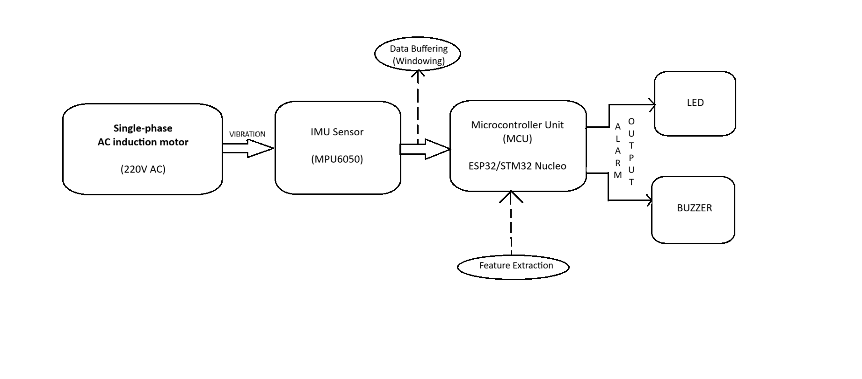

Everything after the sensor happens on the microcontroller itself; no data leaves the device at any stage of real-time operation. This is the core design justification for calling this an edge/TinyML solution rather than a connected IoT system.

12.Flowchart 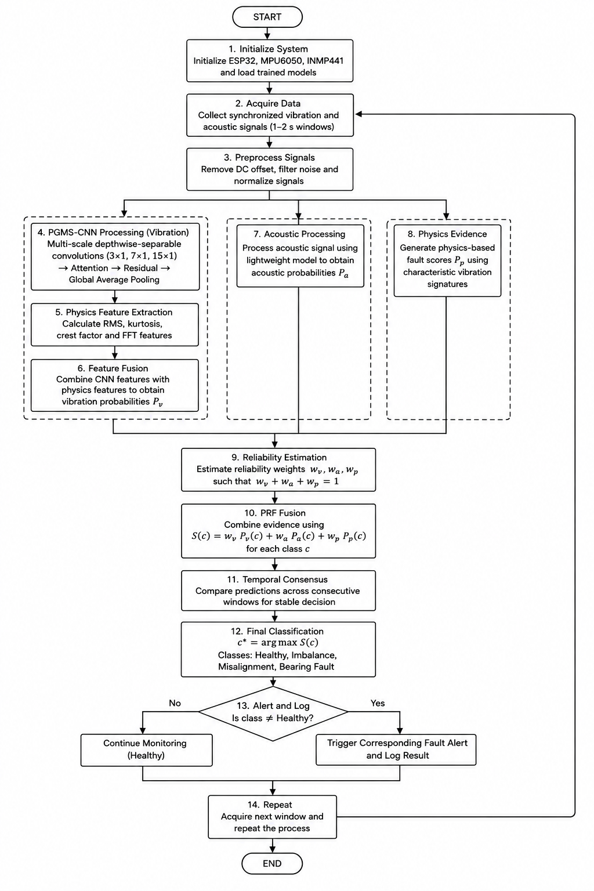

ALGORITHM
- Initialize System – Initialize ESP32, MPU6050, INMP441 and load the trained PGMS-CNN and acoustic models.
- Acquire Data – Collect synchronized vibration and acoustic signals in fixed 1–2 s windows.
- Preprocess Signals – Remove DC offset, filter noise and normalize the acquired signals.
- PGMS-CNN Processing – Apply multi-scale depthwise-separable convolutions (3×1, 7×1, 15×1), followed by attention, residual learning and Global Average Pooling to learn vibration patterns at different temporal scales.
- Physics Feature Extraction – Calculate RMS, kurtosis, crest factor and FFT features to represent physical vibration characteristics.
- Feature Fusion – Combine learned PGMS-CNN features with physics-based features to obtain vibration probabilities Pᵥ.
- Acoustic Processing – Process the acoustic signal using the lightweight model to obtain acoustic probabilities Pₐ.
- Physics Evidence – Generate fault scores Pₚ using characteristic signatures such as 1× components for imbalance, 2× components/harmonics for misalignment and impulsive/high-frequency characteristics for bearing faults.
- Reliability Estimation – Estimate the reliability of vibration, acoustic and physics evidence using signal quality and model confidence, with wᵥ + wₐ + wₚ = 1.
- PRF Fusion – Combine the three evidence sources using S(c) = wᵥPᵥ(c) + wₐPₐ(c) + wₚPₚ(c) for each fault class c.
- Temporal Consensus – Compare predictions across consecutive windows to improve decision stability and reduce transient false classifications.
- Final Classification – Select the class with the highest fused score, c* = arg max S(c), from Healthy, Imbalance, Misalignment and Bearing Fault.
- Alert and Log – Continue monitoring for Healthy operation; otherwise generate the corresponding fault alert and store the classification result.
- Repeat – Acquire the next window and continuously repeat the classification process.

13.Hardware Requirements
Component | Purpose
ESP32 Development Board | Primary microcontroller for sensor interfacing, signal preprocessing, PRF-TC algorithm execution, and TinyML inference.
MPU6050 Accelerometer/Gyroscope | Primary vibration sensor for capturing three-axis motor vibration data through I²C.
INMP441 Digital MEMS Microphone | Acoustic sensor for capturing motor sound/vibration-related acoustic information through I²S for the cross-modal fusion stage.
Test motor / pump with mounting bracket | Physical system under test for vibration data collection
LED / Buzzer | Alarm output on fault classification
SD card module (optional) | Local data logging for offline analysis

14.Software Requirements
Tool | Purpose
Python 3.x (TensorFlow/Keras, scikit-learn, NumPy, SciPy, Pandas, Matplotlib) | Feature extraction, model training, and evaluation
Arduino IDE | Firmware development and board flashing
TensorFlow Lite for Microcontrollers | On-device model inference
Edge Impulse (optional) | Supporting pipeline for data collection and deployment

15.Expected Outcomes
A working prototype capable of classifying a motor's health state (healthy vs. fault) in real time, entirely on-device, with no cloud dependency, along with a documented Phase-I report covering design, implementation, and validation results, in line with the Review-I, Review-II, and Phase-I Review milestones of the academic calendar.

16.Innovation and Novelty
While vibration-based fault diagnosis and TinyML deployment have each been studied independently in prior literature, this project integrates both into a single, low-cost, standalone prototype validated on custom-collected motor data rather than relying solely on public benchmark datasets. The system's ability to operate with zero cloud dependency, combined with an estimated hardware cost under ₹4,000, differentiates it from existing industrial vibration monitoring solutions that typically require expensive data-acquisition hardware and continuous connectivity.

17.Applications
- Small and medium manufacturing units seeking low-cost predictive maintenance.
- Pump stations and HVAC systems requiring standalone motor health monitoring.
- Retrofit fault-detection module for legacy motors without built-in monitoring.
- Agricultural machinery operating in areas with limited network connectivity.
- Educational demonstration platform for edge AI and embedded ML concepts.

18.Future Scope
- Extend the system to detect additional fault classes beyond unbalance and misalignment (e.g. bearing wear, looseness).
- Add acoustic sensing as a complementary modality alongside vibration data.
- Incorporate wireless (BLE/Wi-Fi) logging of fault events to a local dashboard, while keeping inference on-device.
- Explore federated learning across multiple deployed units to improve model generalization without centralizing raw data.
- Extend to unsupervised/self-supervised anomaly detection to catch fault types not seen during training.

19. Project Timeline (Gantt Chart)
The timeline below follows the department's academic calendar for A.Y. 2026-27, Semester-I, Project Phase-I.
Activity | 23-31 Jul | 1-5 Aug | 6-22 Aug | 23-31 Aug | 1-12 Sep | 13-30 Sep | 1-15 Oct | 16-24 Oct
Group Formation | ✓
Guide Allocation | ✓
Topic Selection | ✓
Literature Survey | ✓ | ✓
Problem Identification | ✓ | ✓
Synopsis Preparation | ✓ | ✓
Review-I |  | ✓
Hardware/Software Identification |  |  | ✓
Procurement |  |  | ✓ | ✓
Software Track (Baseline Model) |  |  | ✓ | ✓
Sensor Bring-up & Data Collection |  |  |  | ✓ | ✓
Review-II |  |  |  |  | ✓
System Design |  |  |  |  | ✓ | ✓
Model Training & Quantization |  |  |  |  |  | ✓
Firmware Integration & Testing |  |  |  |  |  |  | ✓
Documentation |  |  |  |  |  | ✓ | ✓
Phase-I Review (Demo) |  |  |  |  |  |  |  | ✓

20.Expected Budget
Sr. No. | Item | Estimated Cost (₹)
1 | ESP32 Development Board | ₹400–700
2 | MPU6050 Accelerometer/Gyroscope | ₹250–400
3 | INMP441 Digital MEMS Microphone | ₹100–200
4 | Test Motor / Pump + Mounting Bracket | ₹800–1,500
5 | Mounting bracket, wiring, LED/buzzer | ₹300–500
6 | SD card module (optional) | ₹100–200
 | Total (Approximate) | ₹2,000–₹3,500
.

21.SDG Mapping (United Nations Sustainable Development Goals)

SDG | Goal | Relevance to This Project
SDG 9 | Industry, Innovation and Infrastructure | Development of a low-cost, embedded AI-based predictive maintenance solution for industrial motors, applying TinyML and edge computing to build innovative digital infrastructure.
SDG 12 | Responsible Consumption and Production | Predictive maintenance extends equipment lifespan and reduces waste from premature part replacement and unplanned failures.

22. Course Outcomes / Program Outcomes Mapping (NBA)
The project maps to the following Course Outcomes (COs) and Program Outcomes (POs) as per NBA accreditation guidelines:
Course Outcome (CO) | Mapped Program Outcomes (POs)
CO1: Identify and analyze real-world problems requiring engineering solutions. | PO1, PO2
CO2: Design and develop a software system using modern tools and AI techniques. | PO3, PO5
CO3: Apply AI/ML and NLP concepts to solve domain-specific problems. | PO1, PO4
CO4: Function effectively as part of a team on a multidisciplinary project. | PO9
CO5: Communicate project outcomes effectively through documentation and presentation. | PO10
CO6: Understand the societal and ethical impact of the proposed solution. | PO6, PO8

23.References (IEEE Format)
[1] R. David et al., "TensorFlow Lite Micro: Embedded Machine Learning on TinyML Systems," in Proc. Machine Learning and Systems (MLSys), vol. 3, 2021, pp. 800–811.
[2] J. P. B. Lima, "Real-Time Fault Detection in Induction Motors Using TinyML: An Evaluation of the Edge Impulse Platform," IEEE, 2025.
[3] T. Jalonen, M. Al-Sa'd, S. Kiranyaz, and M. Gabbouj, "Real-Time Vibration-Based Bearing Fault Diagnosis Under Time-Varying Speed Conditions," arXiv:2311.18547, 2023.
[4] N. Schizas, A. Karras, C. Karras, and S. Sioutas, "TinyML for Ultra-Low Power AI and Large Scale IoT Deployments: A Systematic Review," Future Internet, vol. 14, no. 12, p. 363, 2022.
[5] S. Arciniegas, D. Rivero, J. Piñan, E. Diaz, and F. Rivas, "IoT Device for Detecting Abnormal Vibrations in Motors Using TinyML," Discover Internet of Things, vol. 5, no. 1, p. 41, 2025.

